**On 18-11-24:**

1. Need to add the project name in the Login page.
2. After login, Need to add the sankara copy rights details at the footer of every home page.
3. Forget password-Mail check message page, text is not easy to visible. In this page need to change the text “Hi, Check your mail” into “Confirmation ”

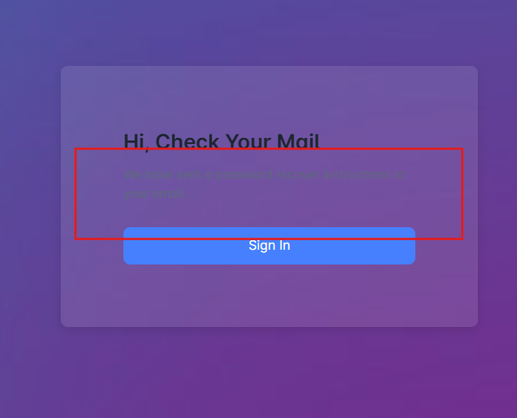

1. Forget password- Without enter email id in login page, and click Forget password button page moves to next activity. But it only works once the user enter the respective email id and click forget password button then only it goes to next page.
2. Forget password-After click forget password, enter email address should not display, it should automatically get the email id from the login page and here only confirmation message should display.
3. Forget password-After click forget password, enter valid email id and clic submit button, it takes more than 5-10 secs.
4. Forgot password- Reset page- Need to add the password requirements in the page.
5. Forgot password- Reset page- After enter the password without upper case and special characters password gets accepted but it should not accept.
6. After login, profile button is not easy to visible(Left bottom corner).
7. Product Admin-In the table/Grid, without upload profile image, the image should show the first letter of the admin name, but here every image displayed with “A” letter.
8. Product Admin-In the table/Grid, in action column extra button(View button) is hiding and it is able to clickable.

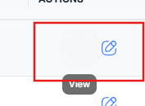

1. Product Admin-In the table/Grid, in action column edit button displayed in right alignement it need to show left alignment.
2. Product Admin-In this page two module path details is displayed need to remove the unwanted path details.

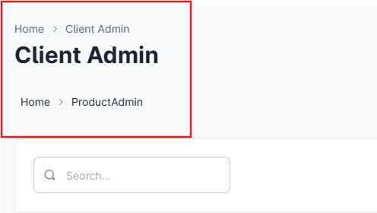

1. Product Admin-In the table/Grid, second column name need to change from “Customer name” to “Product admin name”
2. Product Admin-In the table/Grid, after apply filter first column numbers doesnot displayed properly with ascending order. It should be static and it should not change apply any kind of filter to the table.

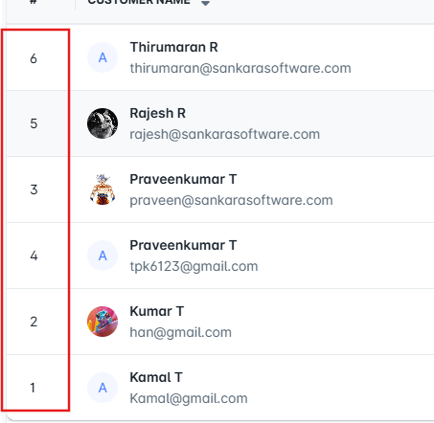

1. Product Admin- Need to change the sub-heading “Add User” into “Add Client Admin”.
2. Product Admin-After click add new button, without enter any details and click anywhere with in the page, mandatory message is displayed but it need to show once click the save button.
3. Product Admin-After click add new button, text cursor is present in Last name tab but it should present in the First Name tab after enter into client admin page.

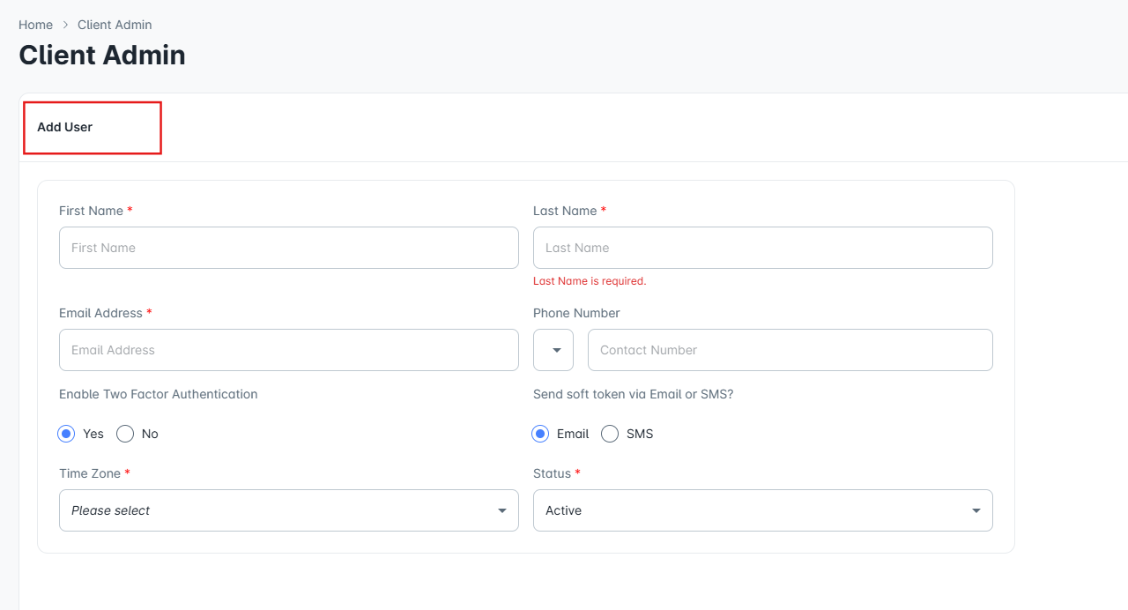

1. Product Admin- Add new-Need to remove scroll option.
2. Product Admin- Add new-After enter valid details and click save button, save functionality performance is too slow and it nearly take more than 5-10 Secs.
3. Product Admin- Add new- Need to add the upload profile photo option without mandatory field. (Upload option should present both Add and Edit pages not only in edit page).
4. Product Admin- Add new- Phone number field accept both alpha and special characters.
5. Product Admin- Add new- Without enter the country code in phone number field and click save button page is gets accepted the details.
6. Product Admin- Add new- Need to fix the maximum digits Phone number field and user should not able enter more than maximum digits(Fix upto 10digits).
7. Product Admin- Add new- Need to add mandatory symbol in phone number field.
8. Product Admin- Add new-Need to remove mandatory symbol in time zone field.
9. Product Admin- Add new-Email field doesnot check the domain names properly. For Example, create a admin detail, in email field without enter “.com” tab accepts the mail id and saved without any issues.
10. Product Admin- Add new-without enter any detail and click save button, mandatory message is displayed only in last name filed and other mandatory tabs are not displayed the mandatory messages.
11. Product Admin-After a product admin status is changed to “Inactive” and tried to login the same admin user id and password, the error message is displayed like “User not registered” but it need to show a alert message like “We locked your account and please contact the admin for further”
12. Product Admin-Click Edit for any admin- after click clear button, Timezone value should show “Please select” option and it should not display empty value.
13. Product Admin-Click Edit for any admin- after click clear button, status tab value should show “Active” option and it should not display empty value.
14. Product Admin-Click Edit for any admin- 2FA and Send soft token radio button should move to default position and it should not show empty status.(Radio button should not remove at any suitation).
15. Product Admin-Click Edit for any admin- Click Change password- First tab name should named as “current password” not “Old password”.
16. Product Admin-Click Edit for any admin- Click Change password- Need to remove cancel option(Because back button is already present) and change into clear option.
17. Product Admin-Click Edit for any admin- Click Change password- When enter the new and confirm password doesnot match with the requirement and click save button, page accept the password and success message is displayed.
18. Product Admin-Add new-Enter already saved details and click save button, no error message is displayed. Need to show, user already exists alert message.
19. Product Admin-Click Edit for any admin- Click Change password- When enter previously registered old password in new and confirm field and click submit, no activity is happened in the page and no error message is displayed.
20. Client Admin-In this page two module path details is displayed need to remove the unwanted path details.

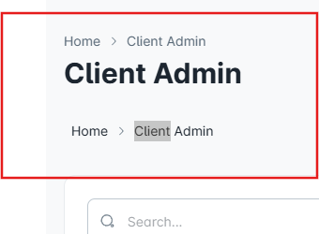

1. Client Admin-In the table, action column alignment is not proper.
2. Client Admin-In the table, delete button is not working.
3. Client Admin-Add new-Extra grey border is displayed.

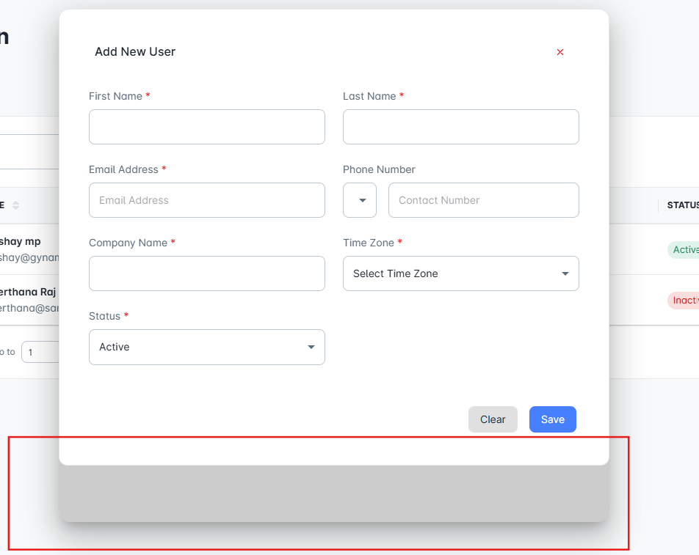

1. Client Admin-Add new-Save functionality is not working.
2. Client Admin-Add new-Heading need to change from “Add new user” to “ Add client admin”.
3. Client Admin-Edit- Heading need to change from “Add new user” to “ Update client admin”.
4. Client Admin-Edit- After remove company name(Mandatory field) and click save button, details gets saved without any issues.
5. Client Admin-Edit- Need to change “save” button into “Update” button.
6. Client Admin-Edit-Try to modify the phone number field, tab response is not proper and country code present with in the tab.

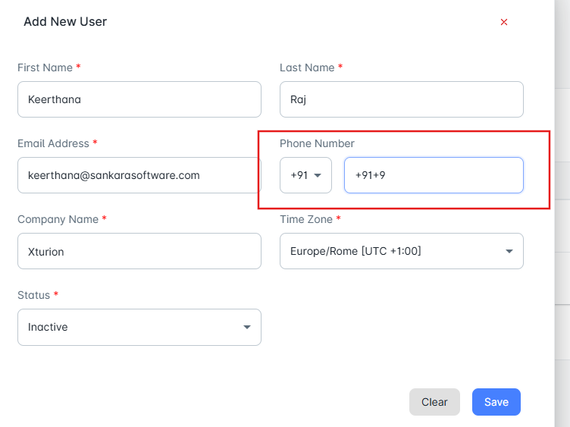

1. Client Admin-Click edit button of any admin and click close button and then again click add new button same user details are displayed here.
2. Client Admin-In the grid-User logo should display the first letter of the client admin name.
3. Client Admin-Click edit button of any admin and update any details and click save button, no success message is displayed, only pop up is closed. And changes also, no immediately reflected in the grid. It only display the changes once user moves to any other page and again back to client admin page then only changes are displayed.